IPF CONNECT
INFORMATION
SYSTEM

User Manual

Using the System as Source

- Login as Hospital Source
  - Hospital source user will login using Login credentials (user id and password).
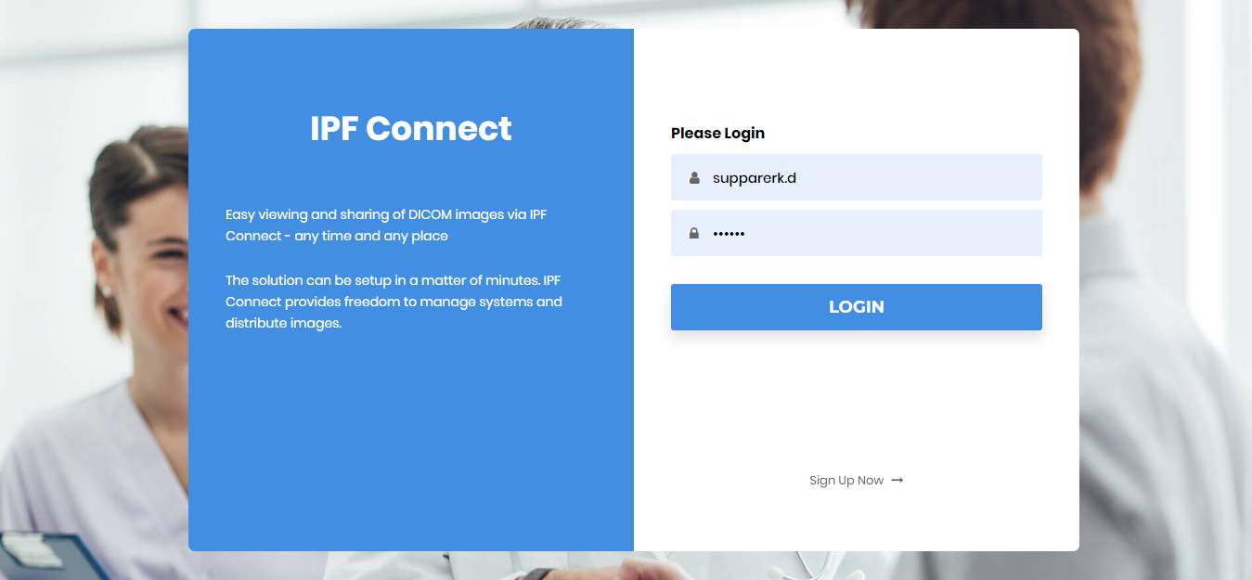

  - After logging in successfully, the source user will view the WorkList. The user will now be able to upload DICOM image using the Upload icon to create a new Study.
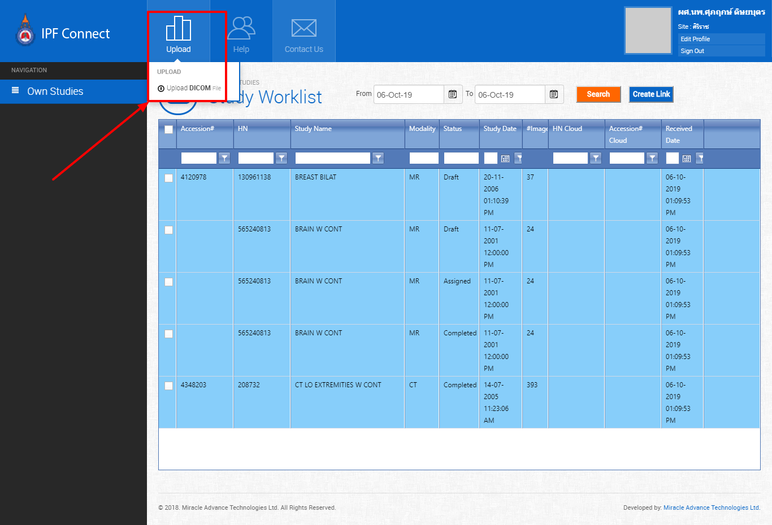

  - Selecting the upload DICOM button will prompt to user to browse the DICOM image using the Select button, which lets the user browse DICOM image from the device.
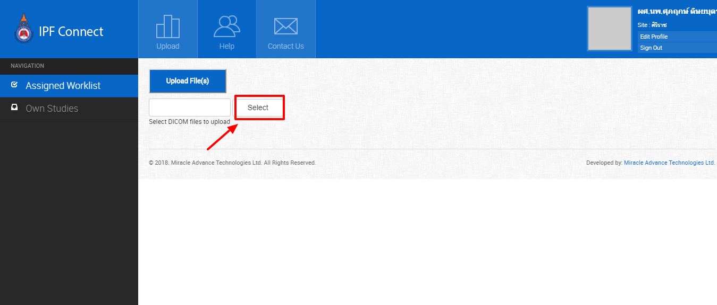

  - Once a DICOM image is selected, the user has to click on Upload File(s) button to upload the image, and a new study will be created in the worklist.

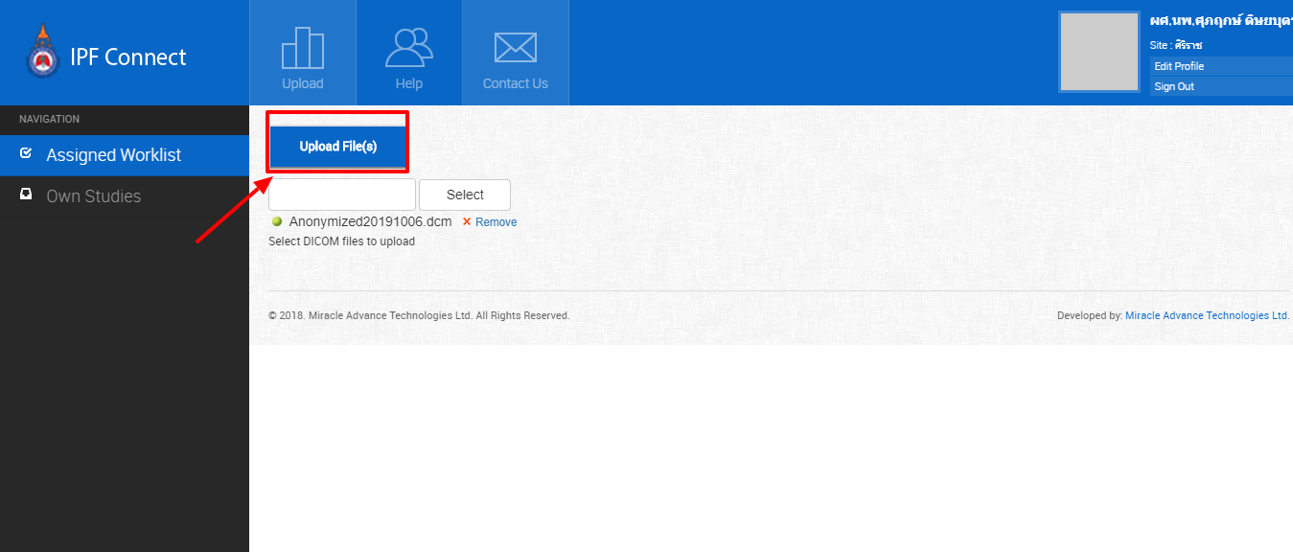

  - Then user will now be able to see the created worklist.

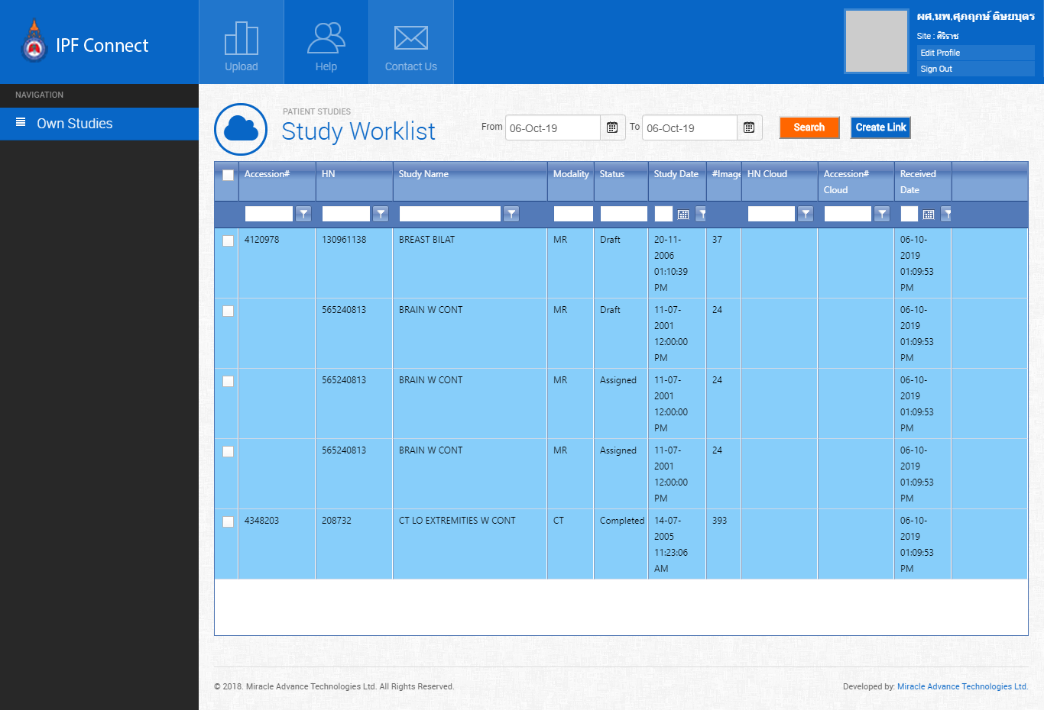

  - The user can now create a link between the two studies.
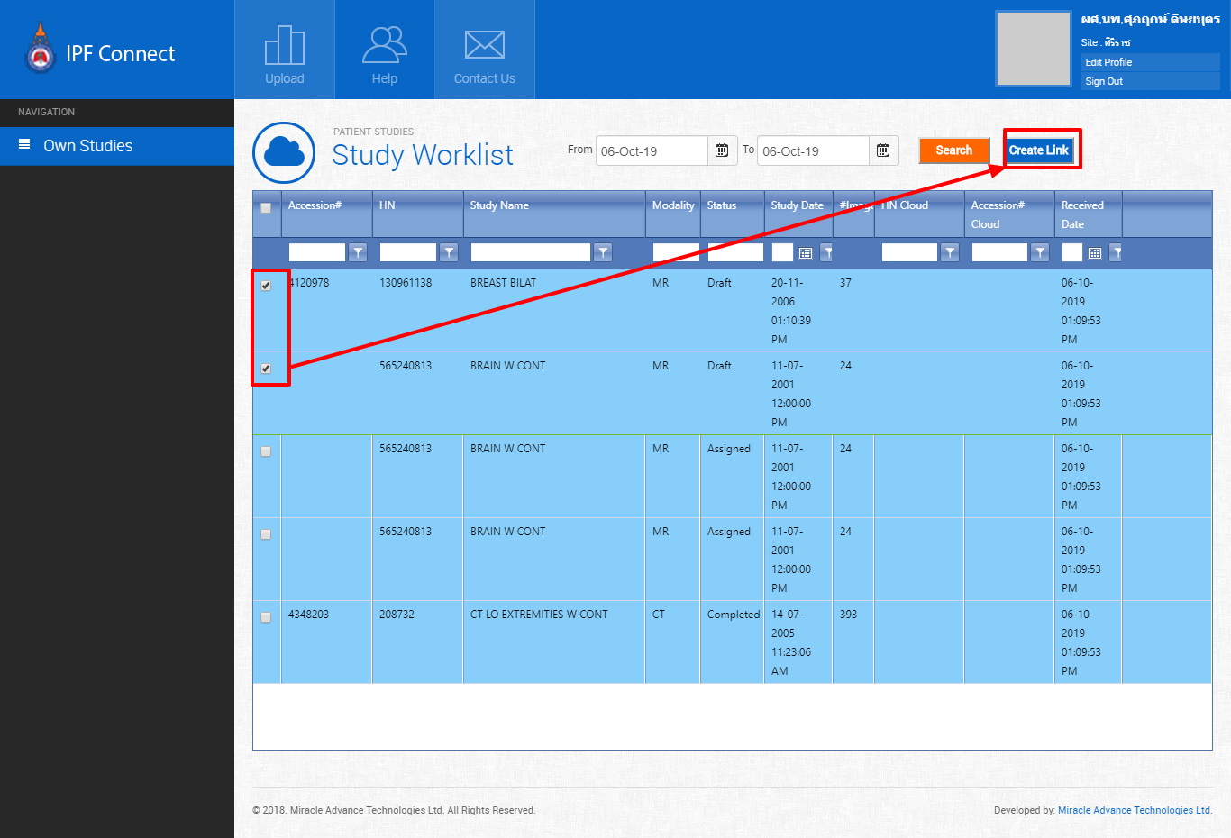

  - To enter assessment data as a draft or as finalized data, the user has to double click on an item from the worklist. The system will then open a dialog box for storing assessment data. Assessment data has to be completed before the data can be finalized. All fields are mandatory.
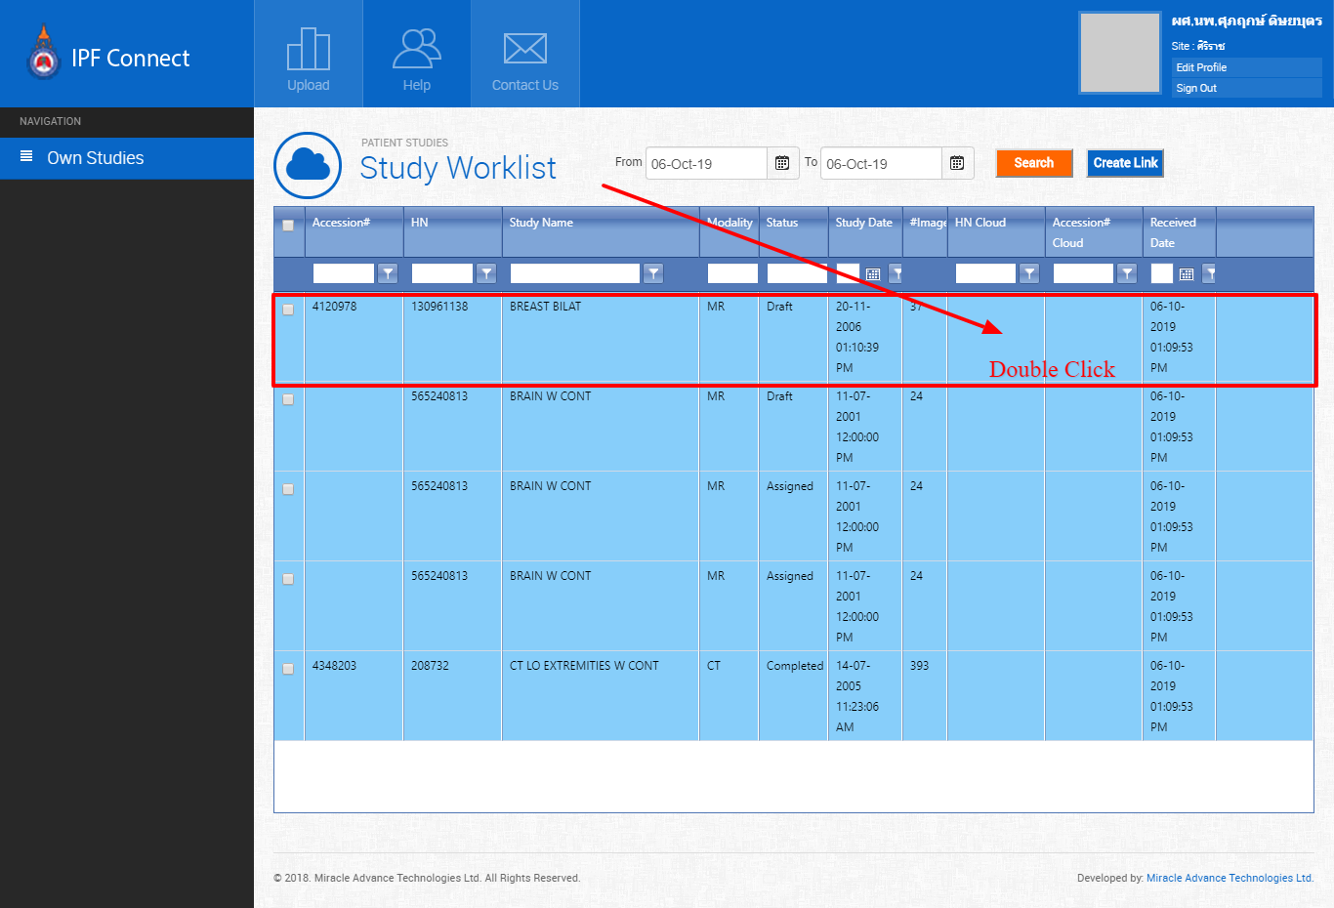

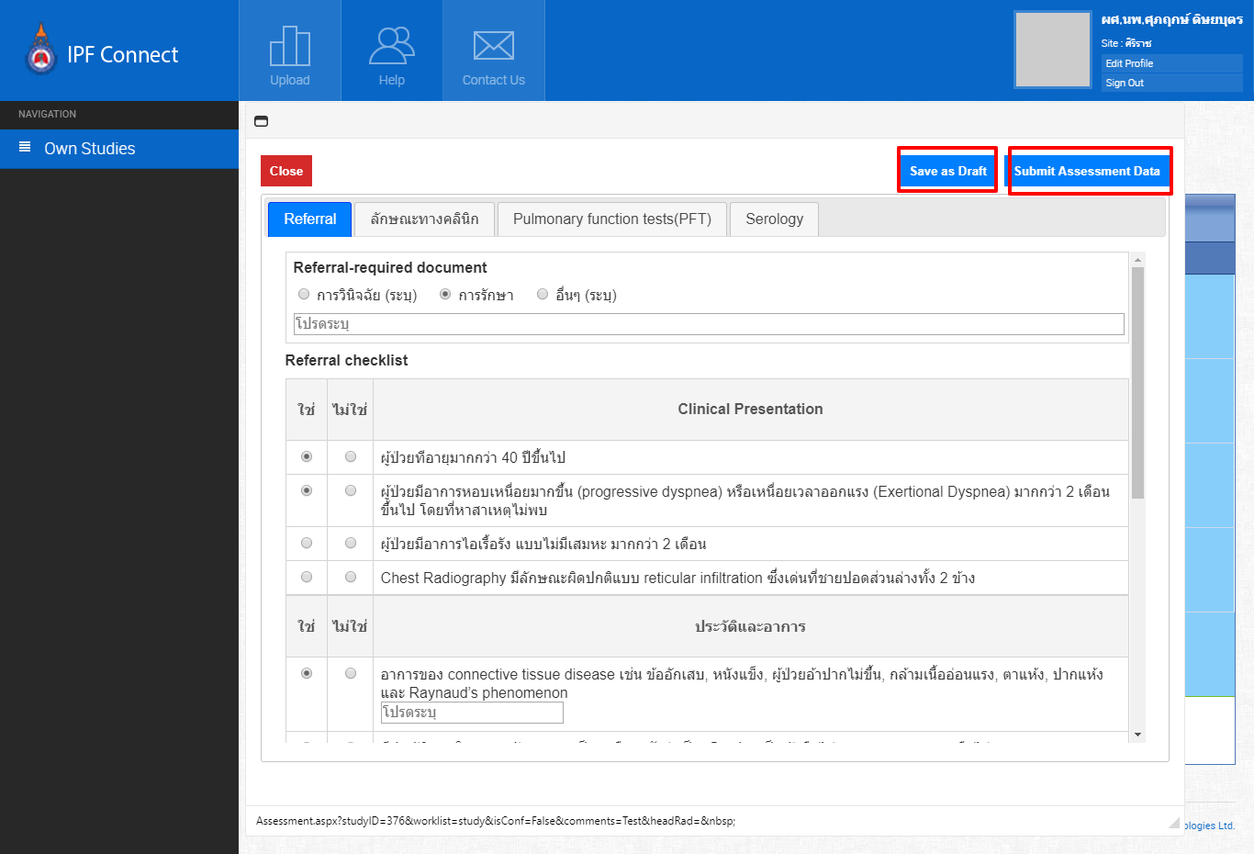

  - The user will get a notification once the Conclusion is ready. The Conclusion from the HON (Head of Node) can be viewed here.

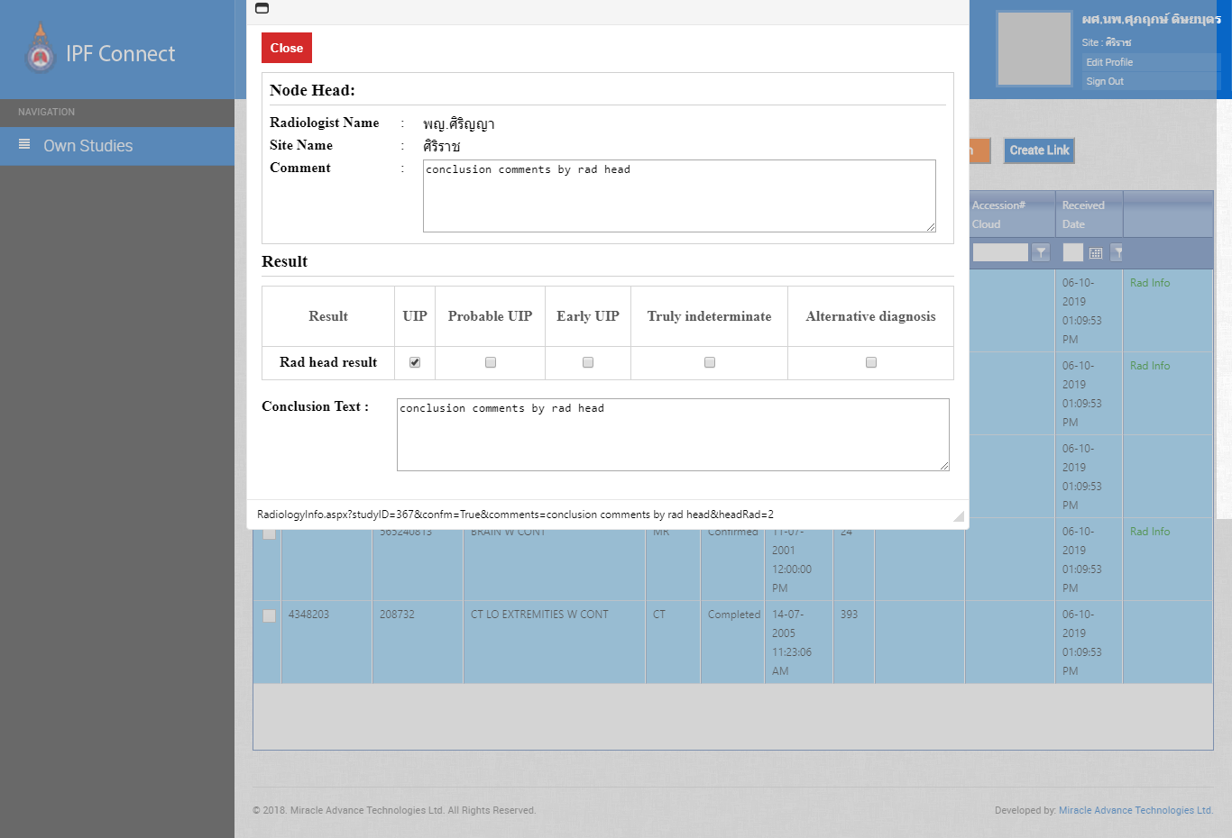

Using the IPF Connect System as Head of Node (HON)
- Login as HON
  - HON users will login using his/her login credentials (user id and password).
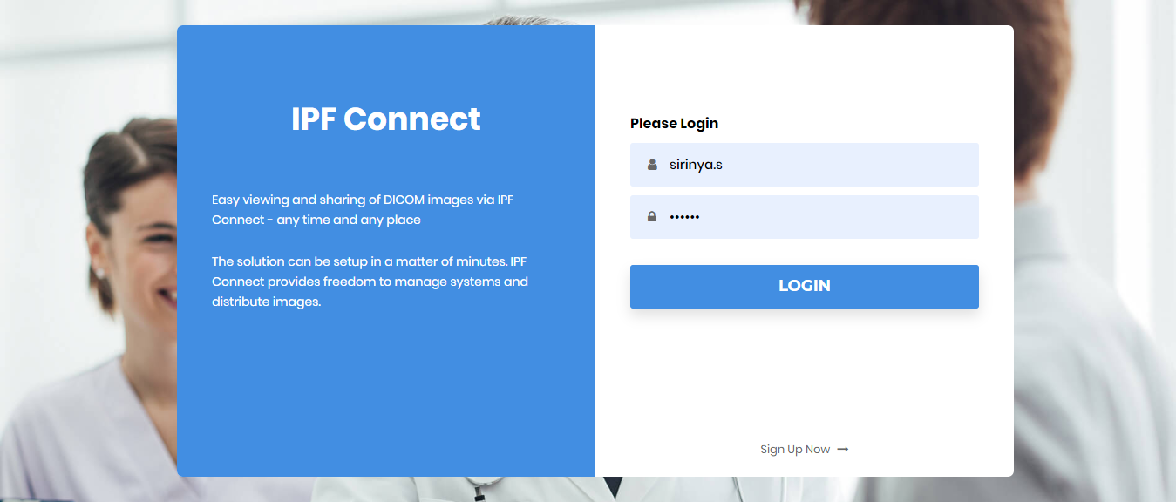

  - Once logged in, a HON user will see the Worklist. The user will able to upload DICOM image to create Worklist and get Worklist which has been already assigned to this user. If the HON wishes to create a new Study, it can be done from the Own Studies tab on the left.
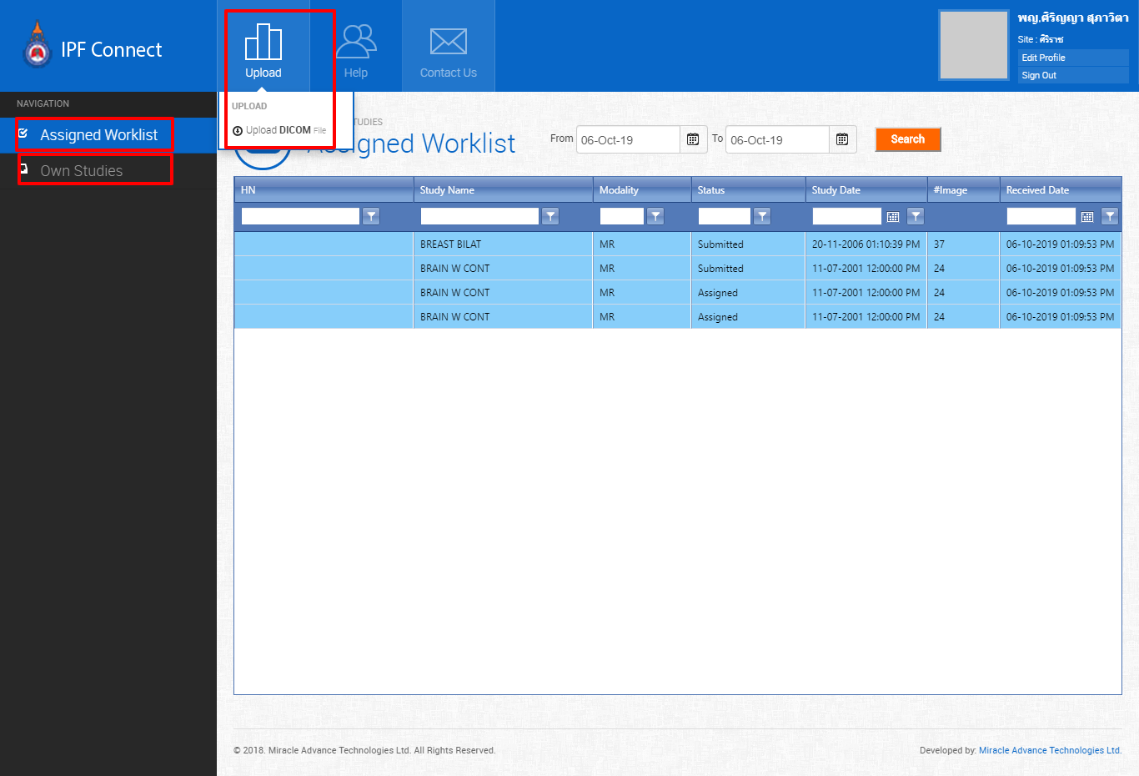

  - Double clicking on an item from the Worklist will open an Assessment form. The HON can decide to either do the reporting by themselves using the Self Reporting option, or assign to a radiologist using Assign Radiologist option. Selecting Assign Radiologist option will assign the case to a radiologist outside of the Node in random.
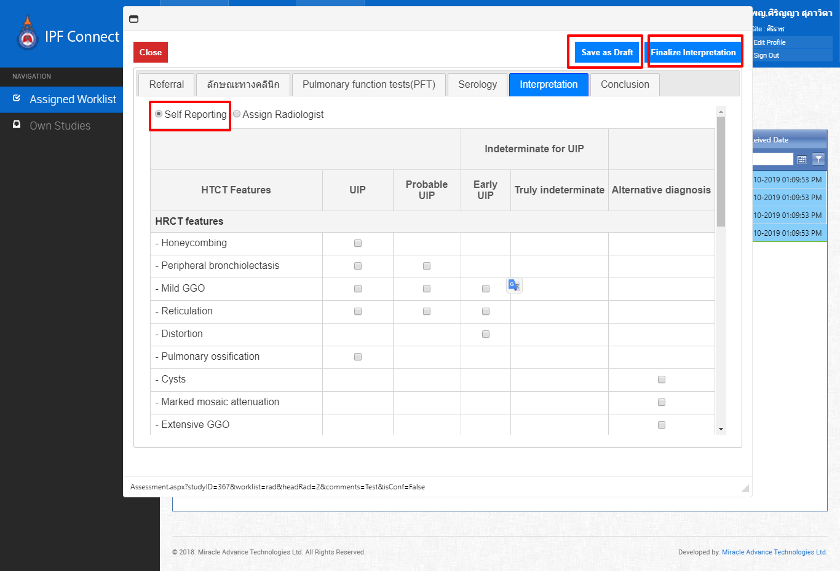

  - HON can write the Conclusion and complete the Study Lifecycle
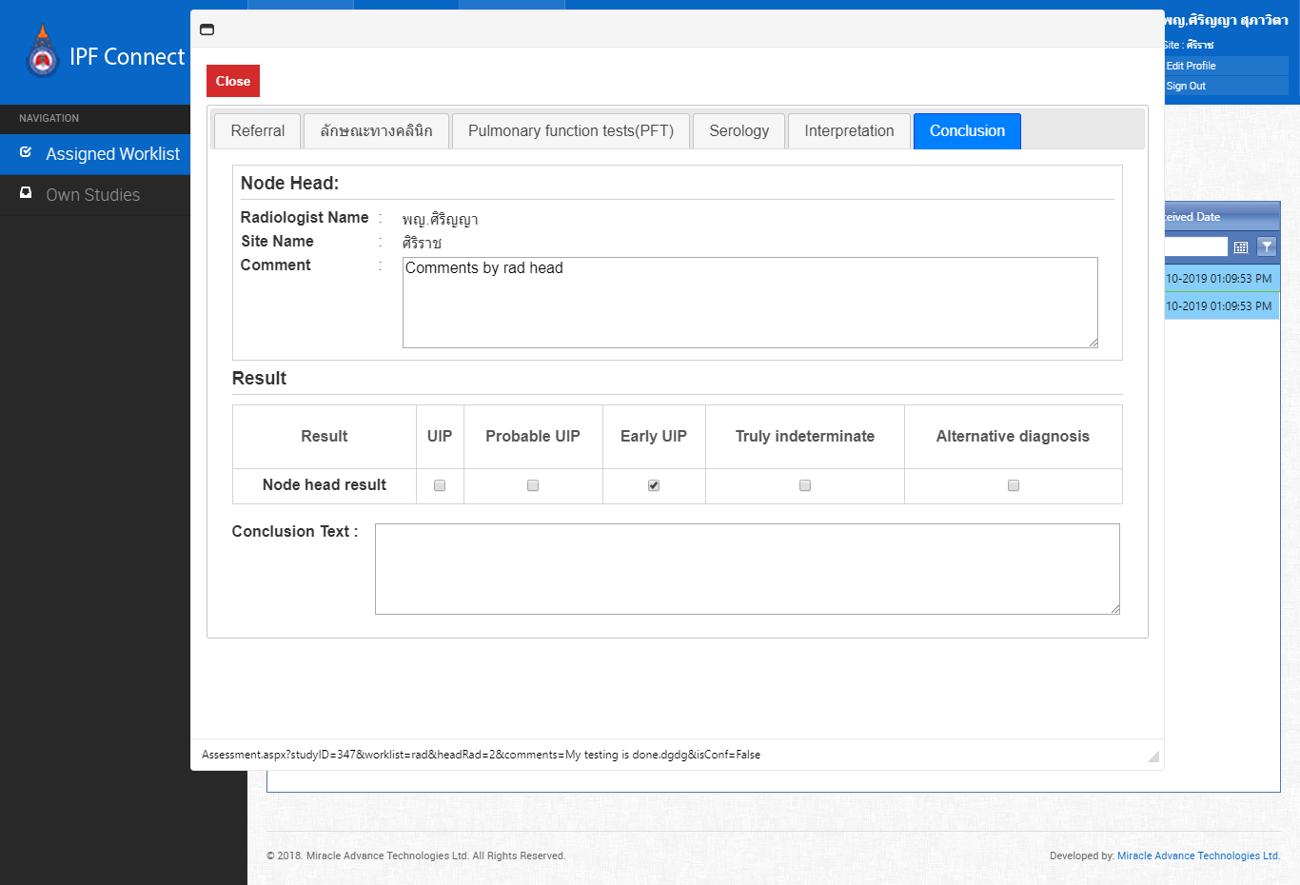

  - Once the HON assigns the study to two of the Radiologists, they will able to see studies assigned to them.
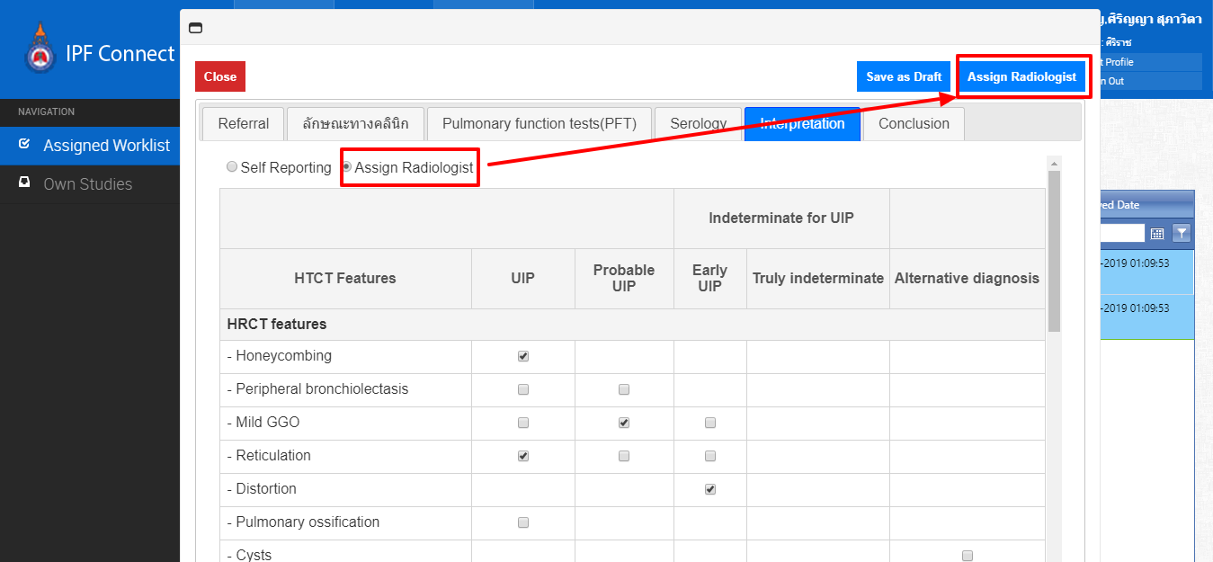

  - After successfully assigning Radiologists, the HON should be able to view the assigned Radiologists inside the Conclusion tab.
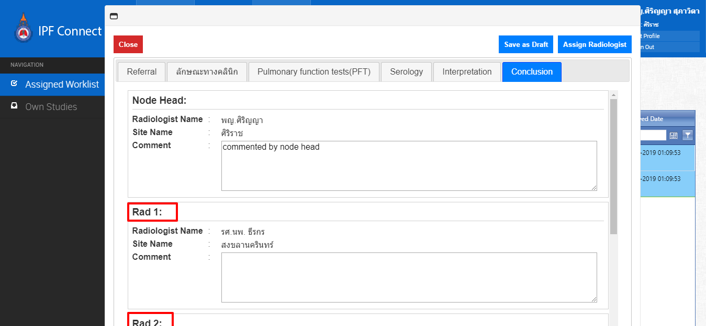

  - After the first and second Assigned Radiologists finalize their results, they will be matched to see if they are the same. If the results for the first two assigned radiologists do not match, a third radiologist (Rad 3) will be assigned.
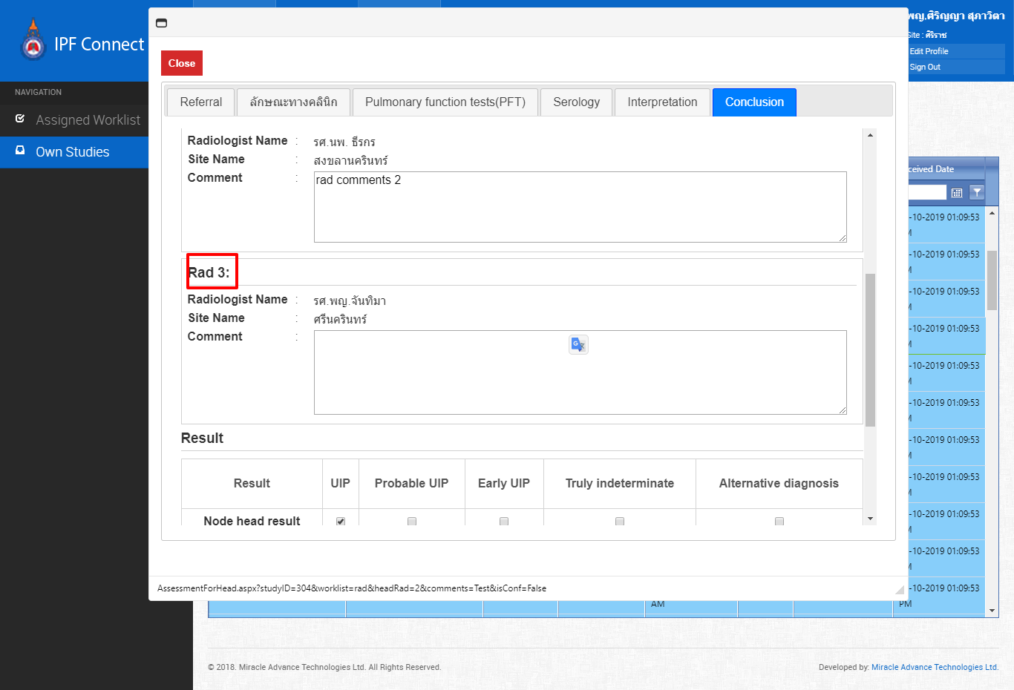

  - Once the First, Second and Third Radiologists finalize their results, the HON will able to view the results and update HON’s result accordingly. The HON can now provide a Conclusion and finalize. After the Conclusion is done by the HON, Source are able to view the final result.

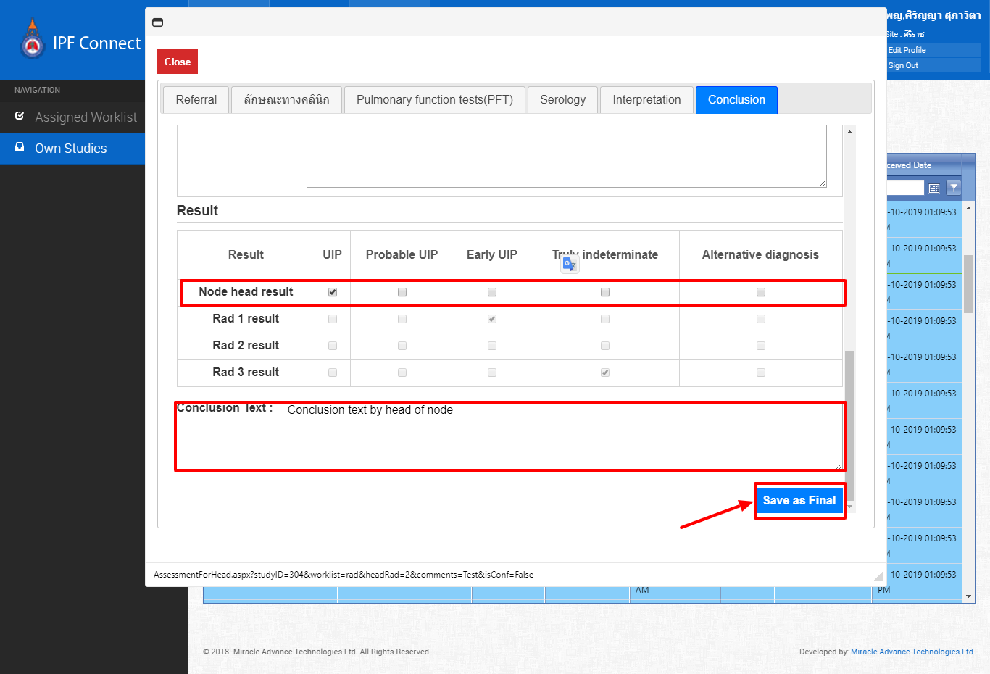

Using the IPF Connect System as Radiologist
- Login as Radiologist

  - The user will log in using proper login credentials (user id and password).
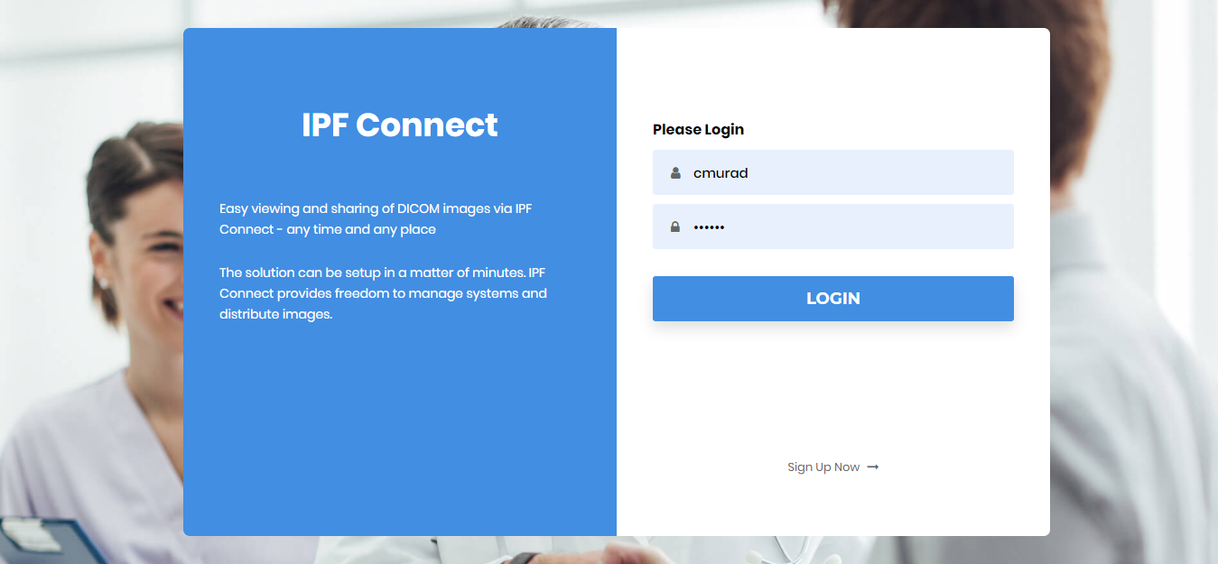

  - Once logged in, the Radiologist will see their Assigned Worklist.
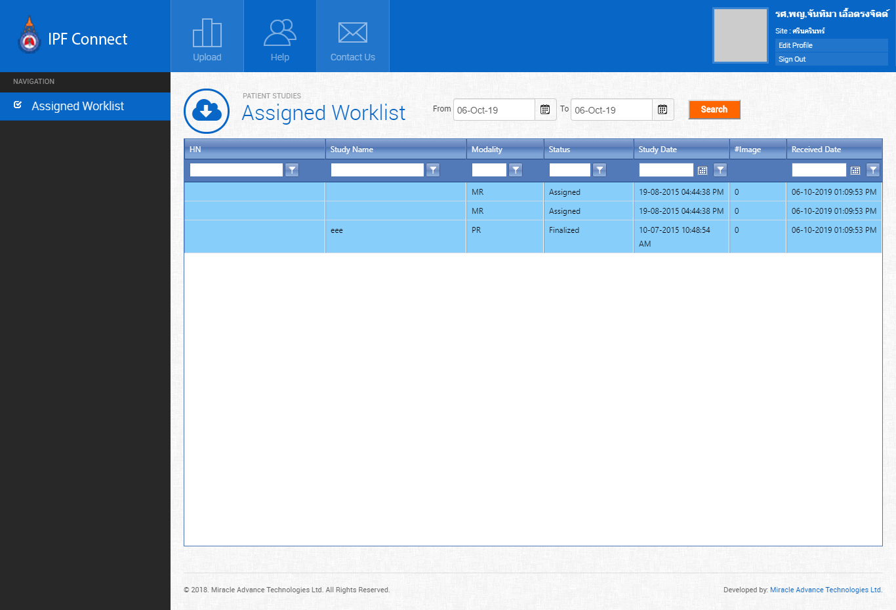

  - To start Interpretation, a Study has to be double clicked, which will open up the Interpretation tab. Radiologists would be able Save as Draft or Finalize Interpretation directly.
    - Save as Draft can be done for any number of times as the user wants
    - Finalize Interpretation can be done just once, and will remove the Study from the Worklist.

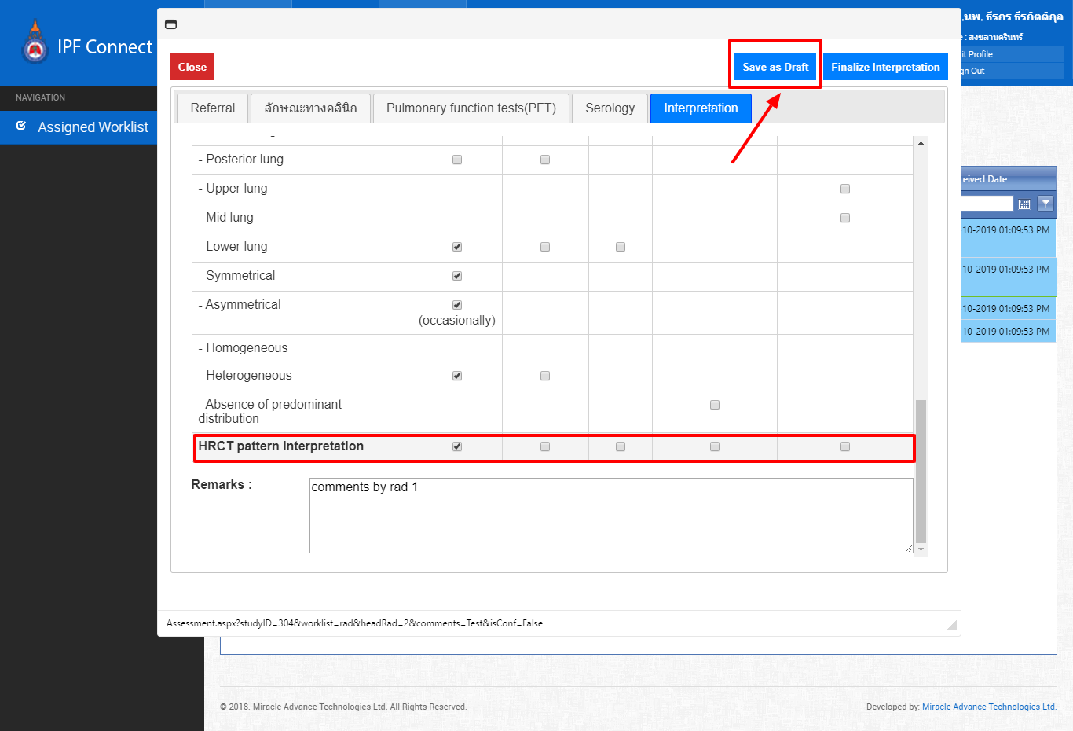

  - Once the user finalizes the study result, the HON will be able to see the results and comments from their worklist.
